

Heat Exchangers and Heat Transfer (2025-2026)
Course code: B51GL
Assignment 2
Radiation

Name: Gauravsingh Rajput (H 00515081)

Radiation/ Convection Network Assessment – System HB

Your thermal system is a small cylindrical furnace. The objects being heated up are cylindrical billets of steel (ρ_{s}=8000 kg/m³ and c_{s}=420 J/kg K), see the figure below.

$$Comb Prods$$
$$Fuel$$
$$Air$$
Surface 1
Surface 3
Surface 2
2m
Surface 4
Surface 5
1m
2m
0.5m

Steel Billet

Figure HB – Furnace dimensions.
This is essentially a technical calculation / analysis of a heat transfer system. There must be sufficient discussion to make it straight forward for the marker to assess a student’s understanding.
Mixed-mode heat transfer
In this section, both radiation heat transfer and convection heat transfer will be considered together. The surface properties are summarised in the table below.

Number of Surfaces=5

Surface | Temperature / K | α /W m⁻²K⁻¹ | Emissivity
1 | 1200 | 20 | 0.8
2 | 1400 | 15 | 0.8
3 | 1600 | 20 | 1
4 | 293 | 15 | 0.5
5 | 293 | 10 | 0.5

Produce a resistance network to include convection between the surfaces and the air in the trough surrounding the steel billet (label the temperature in the trough as T_{gas}).
Assumptions:
- Calculate the temperature of the air in the space surrounding the pipe (T_{gas}).
- Calculate the net radiation heat flux, convective heat flux and total heat flux to all surfaces.
Assuming the net heat fluxes do not change significantly estimate the time it takes for the water in the pipe (hot water system) or steel billet (furnace system) to increase from 293K to 773K and thereby calculate a production rate for this system.

Revision – To calculate the time it takes a mass to heat up is given by the equation.
$${\dot{Q}}_{net}t=mc∆T$$

Solution:
View Factor Section
All 25 view factors must be calculated. The calculation methodology MUST be stated:
Calculating the view factor for surface 5
Reference used: (from book [1] Table 13.4)
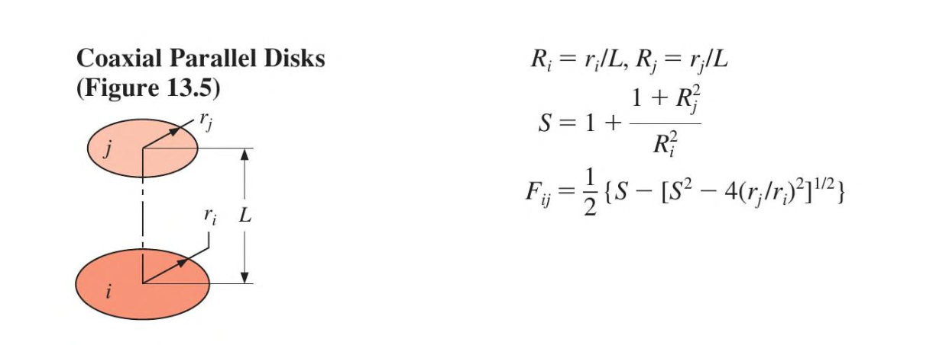

So , for our surfaces ,
r_{i} = 0.5 m , r_{j} = 1m ,L = 2 – 0.5 = 1.5 m, R_{i} = (0.5/1.5) = 0.33, R_{j} = (1/1.5) = 0.66
S = 14.18
F₅₃ = 0.288
F₅₁ = F₅₄ ₌ F₅₅ ₌ 0
So, F₅₁+ F₅₂ + F₅₃ + F₅₄ + F₅₅ = 1
F₅₂ = 0.712
Emitting  (Surface 5) | Receiving surfaces
 | 1 | 2 | 3 | 4 | 5
 | 0 | 0.712 | 0.288 | 0 | 0

Calculating the view factor for surface 3 (Using C41 from Canvas Excel sheet)
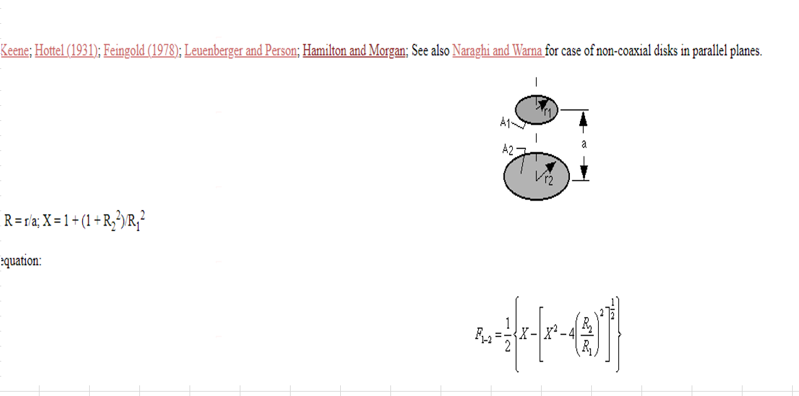

R₁ = R₂ = 0.5
X = 6
F₃₁ = 0.175
As we know, A₃ F₃₅ = A₅F₅₃
So F₃₅ = 0.072
F₃₃ = F₃₄ = 0
F₃₁+ F₃₂+ F₃₃+ F₃₄ + F₃₅ = 1
F₃₂ = 0.753
Emitting  (Surface 3) | Receiving surfaces
 | 1 | 2 | 3 | 4 | 5
 | 0.175 | 0.753 | 0 | 0 | 0.072

Calculating the view factor for surface 1 (Using C77 from canvas excel sheet to find F₄₁ and then doing reciprocity)
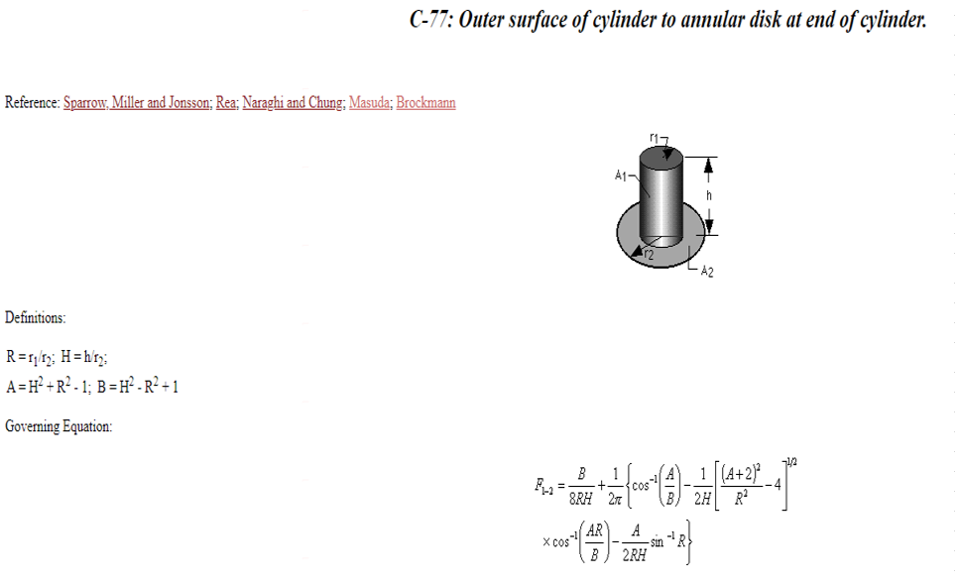

F₄₁ = 0.267(from image)
Using reciprocity,
F₁₄ = 0.267, F₁₃ = 0.175, F₁₂ = 0.558
F₁₁ = F₁₅ = 0
Emitting  (Surface 1) | Receiving surfaces
 | 1 | 2 | 3 | 4 | 5
 | 0 | 0.558 | 0.175 | 0.267 | 0

Calculating the view factor for surface 4

F₄₁ = 0.267(calculated preciously using C77)
F₄₅ = F₄₄ = F₄₃ = 0
Using Reciprocity, F₄₂ = 0.733
Emitting  (Surface 4) | Receiving surfaces
 | 1 | 2 | 3 | 4 | 5
 | 0.267 | 0.733 | 0 | 0 | 0
Calculating the view factor for surface 2
We can find view factor of Surface 2 only by using reciprocity:
Emitting  (Surface 2) | Receiving surfaces
 | 1 | 2 | 3 | 4 | 5
 | 0.139 | 0.262 | 0.188 | 0.366 | 0.0445

Total View Factor Table:
Emitting Surfaces
Receiving Surfaces
 | 1 | 2 | 3 | 4 | 5
1 | 0 | 0.558 | 0.175 | 0.267 | 0
2 | 0.139 | 0.262 | 0.188 | 0.366 | 0.0445
3 | 0.175 | 0.753 | 0 | 0 | 0.072
4 | 0.267 | 0.733 | 0 | 0 | 0
5 | 0 | 0.712 | 0.288 | 0 | 0

Resistance network:
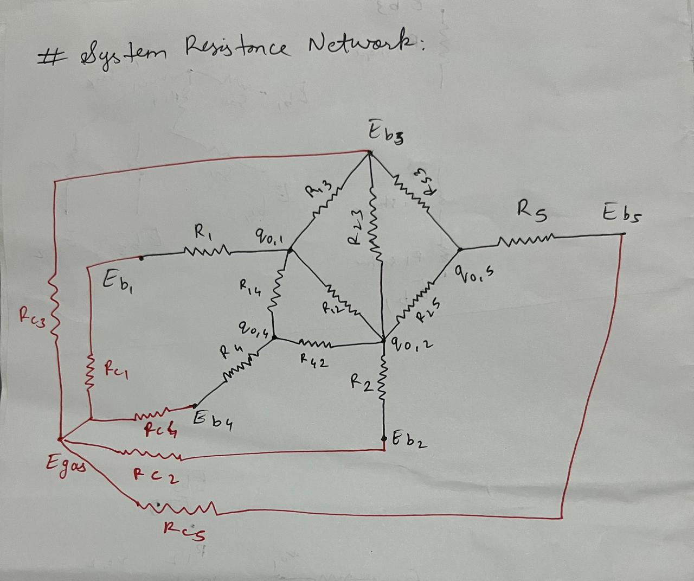
Note: Naming is just for figure I will change it accordingly.

Dimensions of surface:
SURFACE | DESCRIPTION | AREA (m²)
1 | Bottom Surface | 3.1415
2 | Left side wall | 12.566
3 | Top Surface | 3.1415
4 | Billet Side | 1.5707
5 | Billet Top | 0.7853

Total View Factor Table:
Emitting Surfaces
Receiving Surfaces
 | 1 | 2 | 3 | 4 | 5
1 | 0 | 0.558 | 0.175 | 0.267 | 0
2 | 0.139 | 0.262 | 0.188 | 0.366 | 0.0445
3 | 0.175 | 0.753 | 0 | 0 | 0.072
4 | 0.267 | 0.733 | 0 | 0 | 0
5 | 0 | 0.712 | 0.288 | 0 | 0

Surface temperature Table:
Surface | Temperature / K | α /W m⁻²K⁻¹ | Emissivity
1 | 1200 | 20 | 0.8
2 | 1400 | 15 | 0.8
3 | 1600 | 20 | 1
4 | 293 | 15 | 0.5
5 | 293 | 10 | 0.5

σ = 5.67037 × 10-8 W.m-2.K-4

Radiosity (J )
Radiosity is the total radiant energy leaving the surface per unit area and per unit time.
So in our case, G is irradiation and J is the radiosity leaving.
J = εσT⁴+ ρG
For matrix multiplication:
J – ρG = εσT4
J – ρFijJ = εσT4
J (1 - ρFij ) = εσT4
J = (1 - ρFij )⁻¹ * εσT4
X = A⁻¹ B
So radiosity,
Radiosity | W/m² | kW/m²
J₁ | 135758.548 | 135.758
J₂ | 211238.574 | 211.238
J₃ | 371613.657 | 371.613
J₄ | 95751.658 | 95.751
J₅ | 128922.254 | 128.922

Incoming Radiation to each surface (G_{i})
The irradiation received by each surface i is:
$$G_{i}=\sum_{j=1}^{5}{F_{ij}}J_{j}$$

Irradiation (G) | W/m2
G1 | 208469.206
G2 | 184860.459
G3 | 192102.794
G4 | 191085.407
G5 | 257426.597

Total radiative heat surface
The net radiation leaving the surface i ($q_{rad}^{"})$
$$q_{rad,i}^{"}= J_{i}- G_{i}$$
- $q_{rad,i}^{"}>0$ : surfaces lose radiation
- $q_{rad,i}^{"}<0$ : surface gains radiation
Surface | $$q_{rad,i}^{"}= J_{i}- G_{i}$$
1 | -72710.658
2 | 26378.115
3 | 179510.8630
4 | -95333.749
5 | -128504.3430

Total radiative heat transfer ($q_{rad,i}$)
SURFACE | AREA, $A_{i}$ (m2) | FLUX, $q_{rad,i}^{"}$ (W/m2) | TOTAL $$q_{rad,i}= A_{i}×q_{rad,i}^{"}$$  (W)
1 | 3.1415 | -72710.658 | -228420.5321
2 | 12.566 | 26378.115 | 331467.3931
3 | 3.1415 | 179510.8630 | 563933.3761
4 | 1.5707 | -95333.749 | -149740.7196
5 | 0.7853 | -128504.3430 | -100914.4606

Gas Temperature in Furnace (T_gas)
Σ (h×A×T_surface) − Q_total = h×A×T_gas
So, using this formula,
Gas temperature (K) = 1561.721441934695

Convective heat transfer
SURFACE | hi (W/m2K) | Ai (m2) | Ti (K) | $$q_{conv,i}$$
1 | 20 | 3.1415 | 1200 | -22726.9
2 | 15 | 12.566 | 1400 | -30482.87
3 | 20 | 3.1415 | 1600 | 1202.520
4 | 15 | 1.5707 | 293 | -29891.71
5 | 10 | 0.7853 | 293 | -14944.904

Heating time calculation and production rate
Radius of Billet = 0.5 m
Length (L) = 0.5 m
ρ_{s}=8000 kg/m³
c_{s}=420 J/kg K
Volume (v)= $π×r^{2}×L$ = 0.3296 m²
Mass (m) = 8000 * 0.3296 = 2636.8 kg
Q_{net} = Q₄ + Q₅
Qrad,total​=−(149,740.72+100,914.46)=250,655.18 W
Qconv,total​=−(29,891.71+14,944.90)=44,836.61 W
Q_{net} = 295491.79 W
Time (t) Time (t) $=\frac{2636.8×420×(773-293 )}{295491.79}$ = 1799 sec
Production rate 3600 / 1799 = 2 batch per hour (approx)

Conclusion
Overall after solving this problem, it is concluded that radiation is dominant mode of heat transfer in high temperature furnace environment. The calculated value of T_gas = 1561.7 K
At this temperature the production rate of furnace is 2 batches per hour when temperature of 1561.7K is maintained.
Appendix
Code used in python to calculate the values above
import numpy as np
eps = np.array ([0.8,0.8,1,0.5,0.5])
T = np.array ([1200,1400,1600,293,293])
sigma=5.670374419e-8
F = np.array ([
[0,0.558,0.175,0.267,0], # sum= Fij
[0.139,0.262,0.188,0.366,0.0445],
[0.175,0.753,0,0,0.072],
[0.267,0.733,0,0,0],
[0,0.712,0.288,0,0]
])
a = 1-eps #(rho)
D = np.diag(a)
I=np.eye(5)
M = I - D@F
rhs=eps*sigma*(T**4)
J = np.linalg.solve(M,rhs)
print("Matrix M=\n",M)
print("\nRight hand side vector (rhs)=\n",rhs)
print("\nRadiosity vector j (W/m^2) =\n",J)
import numpy as np
F = np.array ([
[0,0.558,0.175,0.267,0], # sum= Fij
[0.139,0.262,0.188,0.366,0.0445],
[0.175,0.753,0,0,0.072],
[0.267,0.733,0,0,0],
[0,0.712,0.288,0,0]
])
J = np.array ([135758.548, 211238.574 , 371613.657, 95751.658 , 128922.254])
G= F@J
print("\nIncoming radiation G (Wlm^2) = \n",G)
import numpy as np
J = np.array ([135758.548, 211238.574 , 371613.657, 95751.658 , 128922.254])
G = np.array ([208469.206,184860.459,192102.794,191085.407,257426.597 ])
A = np.array ([3.1415,12.566,3.1415,1.5707,0.7853])
Q = A * (J-G)
print("Net radiative heat flux from each surface(W) = \\n", Q)
import numpy as np
Q = np.array([-72710.658,26378.115,179510.8630,-95333.749,-128504.343])
A = np.array ([3.1415,12.566,3.1415,1.5707,0.7853])
T = np.array ([1200,1400,1600,293,293])
H = np.array ([20, 15, 20, 15, 10])
n = np.sum(H*A*T) - np.sum(Q)
d = np.sum(H*A)
t_gas = (n/d)
print("Gas temperature (K) = ", t_gas)
import numpy as np
A = np.array ([3.1415,12.566,3.1415,1.5707,0.7853])
H = np.array ([20, 15, 10, 15, 15])
T = np.array ([1200,1400,1600,293,293])
Q = np.array([-72710.658,26378.115,179510.8630,-95333.749,-128504.343])
T_gas = 1561.721441934695
q_conv = H*A*(T-T_gas)
q_t = q_conv + Q
print("\\n Convection rate of each surface = ",q_conv)
print("\\n Total heat flux to all surface = ",q_t)

Reference:
[1] Theodore L. Bergman, Adrienne S. Lavine, Frank P. Incropera, David P. De Witt Fundamentals Of Heat And Mass Transfer, Seventh Edition John Wiley & Sons, Inc. ( 2011)

